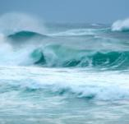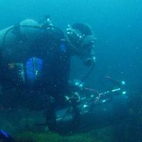

These activities use water themed recordings to inspire different forms of poetry writing including acrostic, concrete and haiku poetry. They are suitable for use with Key Stage 1 and Key Stage 2 classes, and support KS1 & 2 English curriculum topics.
You can find recordings to use with these activities in the ‘Watery’ sound theme in the Minute of Listening application.
On the following pages you will find resources for the following activities:

This starter activity will explore vocabulary the class might use to write their ‘Water’ poetry.

- Using the Minute of Listening application, find the ‘Watery’ sounds in the Sound Themes section (you can reach this through the calendar).

- Using the field recordings of Berlin Rain (week 7, day 5), Waves (week 6, day 1) and Dive (week 12, day 2), ask the pupils to close their eyes and see what pictures these recordings create in their ‘mind’s eye’. Do not reveal the titles of the sounds yet!

- Ask the questions:

What can you see when you hear this sound?
Can you hear or picture a link between all three recordings?

- Discuss the pupils’ ideas and then reveal the titles of the pieces to confirm that the link between them is water.
- Now ask pupils to suggest descriptive vocabulary (encourage and model interesting adjectives of size and colour, onomatopoeic words, alliteration and powerful verbs) to accompany these images, and create a class word bank on the board, large paper or sound cards.

Introduction: These activities use water themed recordings to inspire different forms of poetry writing including acrostic, concrete and haiku poetry. They are suitable for use with Key Stage 1 and Key Stage 2 classes, and support KS1 & 2 English curriculum topics.
Year Groups: KS1 & KS2

Objectives:
> To create different forms of poetry using water themed recordings as a starting point and inspiration.

> To explore the use of descriptive language and sentence structures.
Recordings:
- Waves (week 6, day 1)
- Berlin Rain (week 7, day 5)
- Dive (week 12, day 2)
- The Candlelight Fisherman (week 6, day 2)
- Stretched Lake (week 4, day 2)
- A Walk in the Snow (week 2, day 3)

You can find all these recordings under the ‘Watery’ sound theme in the Minute of Listening application.
Resources you will need:  - Pictures of Hokusai’s The Great Wave  - Large sheets of paper  - Colouring pencils, pens etc | Curriculum links:  English KS1: Spoken language/reading/writing  English KS2: Spoken language/reading/writing

Class Pyramid Poem
(KS1 & 2)

- Begin the session with the introductory activity on the previous page.

- Tell the class that you are going to focus on the recording of Waves to create some new, sound-inspired poems.
Play the Waves recording again and ask the class to listen carefully and see if they can add any more interesting descriptive words to the word bank.

- Start by writing up the words ‘The waves….’. Explain that you are going to make a non-rhyming but descriptive pyramid poem using class suggestions: initially each phrase grows one word at a time, but to complete the poem they can introduce a final clause, including a powerful verb.

For example,

The waves
The enormous waves
The enormous grey waves
The enormous grey churning waves
The enormous grey churning waves crash onto the shore

- Pupils could now be encouraged to write their own Berlin Rain influenced pyramid poems, using their own ideas as well as words from the class word bank. KS2 pupils could also be asked to try and include alliteration and onomatopoeia for maximum dramatic effect.

- Encourage pupils to read out their poems using plenty of expression to convey their dramatic choice of words.

Shape or Concrete Poems
(KS2)

- Begin the session with the introductory activity or class pyramid poem (above). These ideas will be developed and used to create shape poems.

- Tell the class that the shapes used in this type of poem relate to the subject of the poem, so, for example, a poem about a rainbow would be rainbow shaped.

- As they have been listening to Berlin Rain and Waves, their shape poems will be a raindrop shape or a wave shape.

- Ask the pupils to outline a raindrop and wave shape in the air, and think about how these shapes might influence their poems (consider sound and rhythm: you could try saying the example of a wave poem above whilst tracing the wave shape in the air).

- After tracing and discussing their shapes, pupils can start writing their individual poems and make a draft copy of their raindrop or wave shape to organise how they are going to fit their words onto or into it.

- Final copies can be coloured and displayed, and read aloud to the rest of the class.

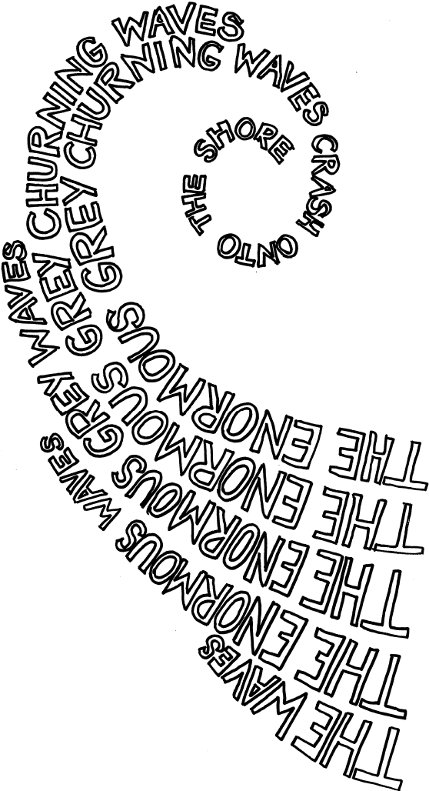'··

2. Haiku Poems

(UKS2)

- Introduce the three recordings as suggested in the introduction activity on page 1, and create a word bank to accompany the Waves recording (ie crashing; churning; colossal; relentless; frightening; energetic).

- Explain that you are going to focus on the Waves recording to write haiku poems.

- Remind pupils that the sea has always influenced and fascinated poets, composers and artists, and that you are also going to look at a well known picture of the sea to help their poetry writing.

- Before you show the picture play the recording of Waves again to remind them of the sound.
Show Hokusai’s The Great Wave print. For your own information and research there is a very good overview of this picture on the British Museum website:

http://www.bbc.co.uk/ahistoryoftheworld/objects/MAPlqOEHRsmI1awIHQzRSQ

- Discuss the picture with the pupils:

What can you see?
Do you think it looks like the sound of the waves you heard? Why/not? Where do you think this might be set and why?
What do you think the artist feels or is saying about the sea in this picture? How do you think the men in the boat are feeling?
Can you add any other words to the Waves word bank now?

- Explain that ‘haiku’ is a Japanese form of poetry that describes thoughts, feelings or moods and in its most popular form it is only three lines long:

5 syllables
7 syllables
5 syllables

Because the form of the poem is very short it is difficult to fit in lots of adjectives and description, so the focus is on precise, well-chosen vocabulary.
- Tell the class that they are going to write a haiku poem, imagining that they are one of the fishermen in the boat in Hokusai’s picture. Remind them of how they previously suggested the fishermen might feel.

- Firstly create a joint class haiku poem, for example

We could see the wave
As we tried to steer the boat Bearing down on us

- Then encourage pupils to work in pairs, or individually, to create an original haiku. When finished, share these haikus amongst the class by reading them aloud.

4. Other ideas for poetry-based activities

- Use Berlin Rain and A Walk in the Snow recordings: write up the titles and ask if they can think of a link
between the two titles.

- Once they spot that they are water-based weather types, ask if they can name any other watery types of weather: sleet; hail; slush; ice; frost etc.

- Play the recordings and ask if they can now spot any differences between the two recordings (one is a field recording and the other is an atmospheric composed piece of music played by an instrumental ensemble).
- Discuss how Berlin Rain and A Walk in the Snow make you feel and build up a list of descriptive words for both recordings.

- At this point it would be possible to start guiding pupils towards writing poetry in the following forms:

focusing on RAIN or SNOW: it can be difficult to make all words start with the same letter but it still works if most words start with the key sound for example:
Soft snow settles slowly making Sharon shiver

spelling out RAIN, SNOW or any of the other watery weather types pupils suggested.

- a similar idea to Haiku, a cinquain is a 5 line poem:

2 syllables
4 syllables
6 syllables
8 syllables
2 syllables

Try using a ‘water’ word as a starting point, for example:

Raindrops
Dripping downwards Joining with the river
In an epic journey seawards Endless

